12.76: a) From the value of at the poles,

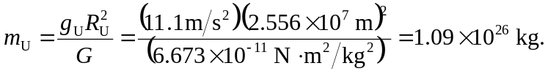
b) d) No; Miranda’s gravity is sufficient to retain objects released near its surface.

